HCS 2017-2018 1st Grade Supply List

1 pair of earbuds  (small ones that can fit inside a snack size baggie) | 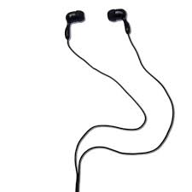
3 containers of bleach wipes | 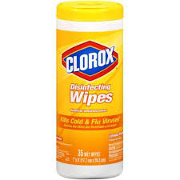
2 bottles of hand sanitizer  (preferably with a pump) | 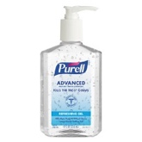
3 boxes of tissues | 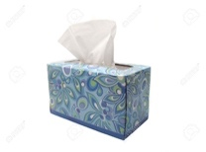
I package hand/baby wipes or napkins  Girls- napkins  Boys- hand wipes | 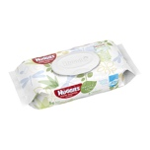 or 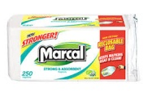
1 pack of markers  (8-12 markers, broad tip, preferably washable) | 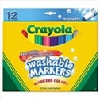
1 pack of pens or pencils  Girls- #2 pencils  Boys- pens | 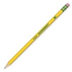 or 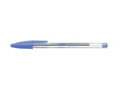
3 glue sticks | 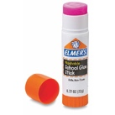
Ziploc Bags  Girls- gallon size  Boys- quart, sandwich, or snack size | 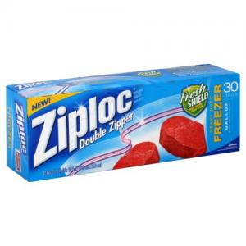

Have fun shopping! See you in September
Love, Ms. Swentzel

